2/25/2023

**Business Analytics Assignment#01**

Name: Saman Khan

ID: 19K-0354

Section: 8-B

Instructor: Dr. Rauf Ahmed Shams

# **Question#01**

## **Stage 1: Initial Access Steps**

## **Installing the App**

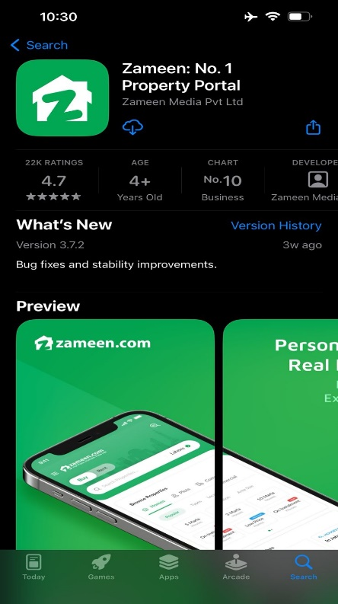

## **Opening the App**

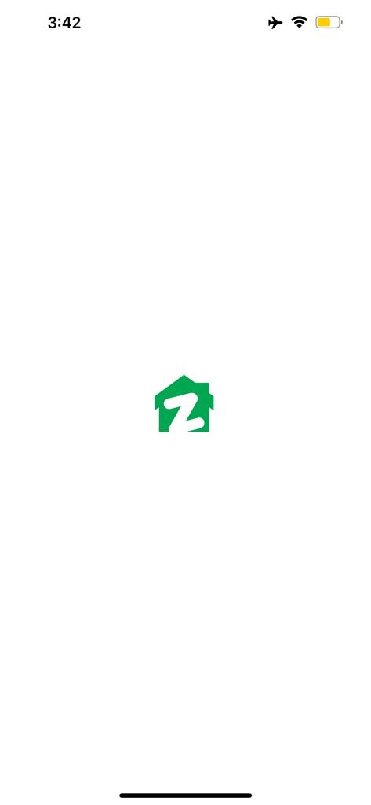

## **Location Access Setting**

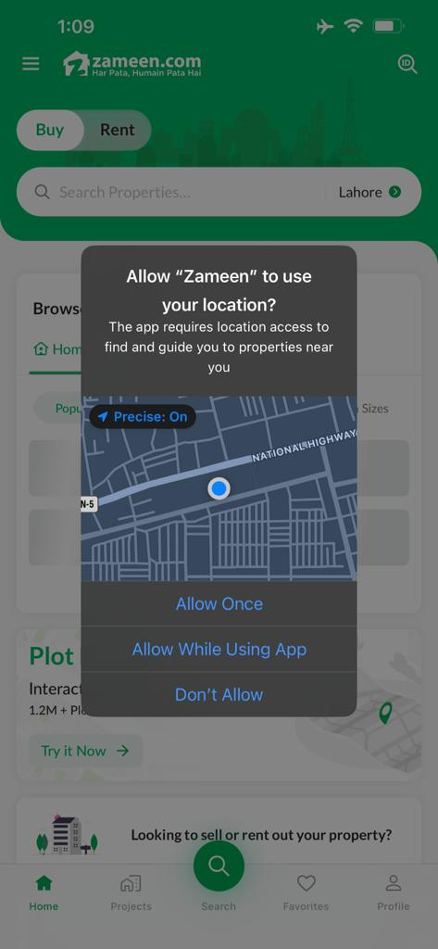

## **Notifications Setting**

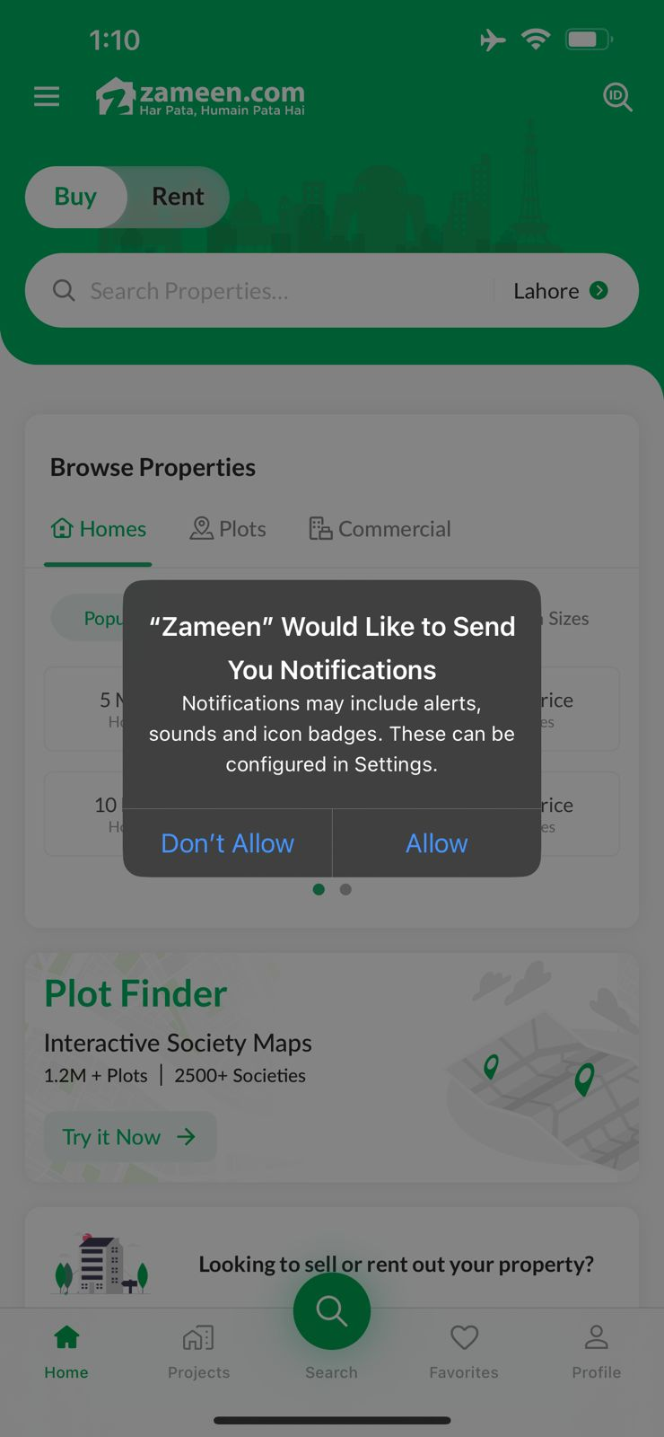

## **Stage 2: Searching Properties for Buying/Renting**

## **Using Browse Properties**

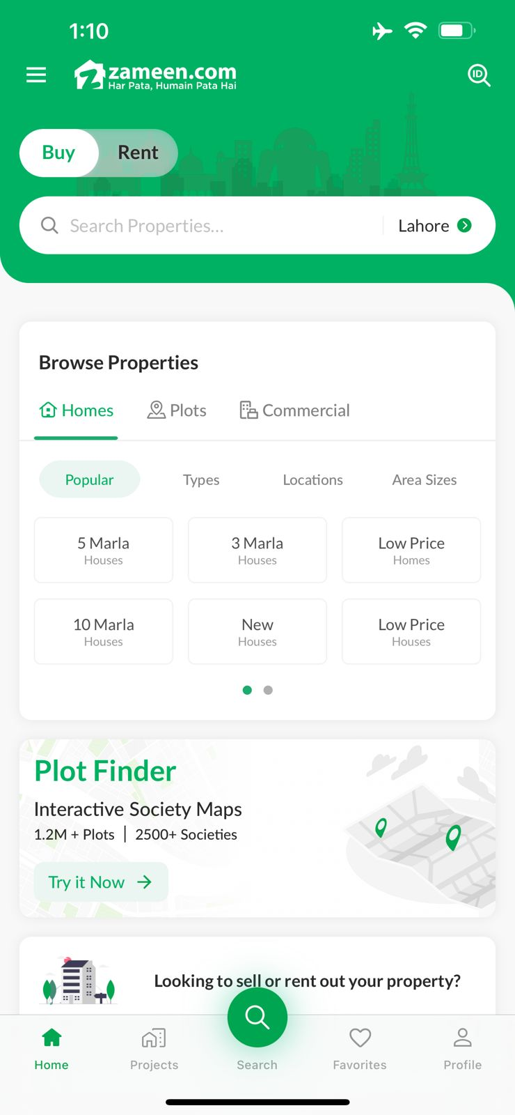

## **Using Property ID**

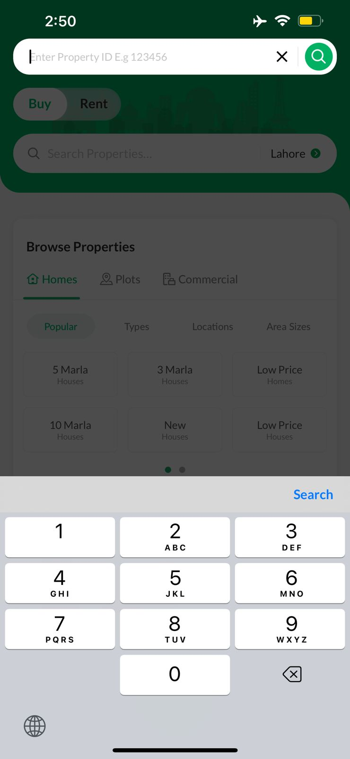

## **Using Property Filters**

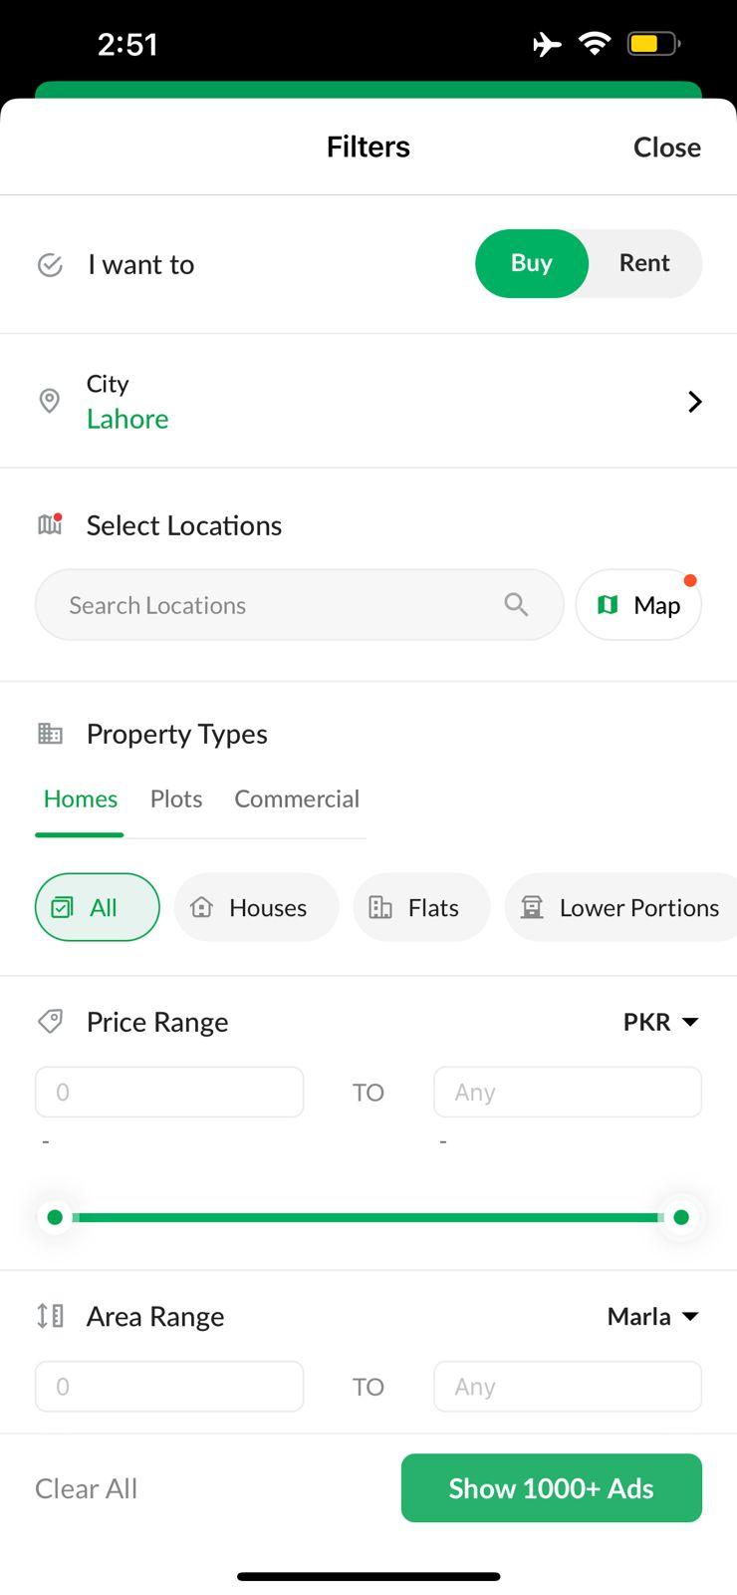

## **Using Plot Finder**

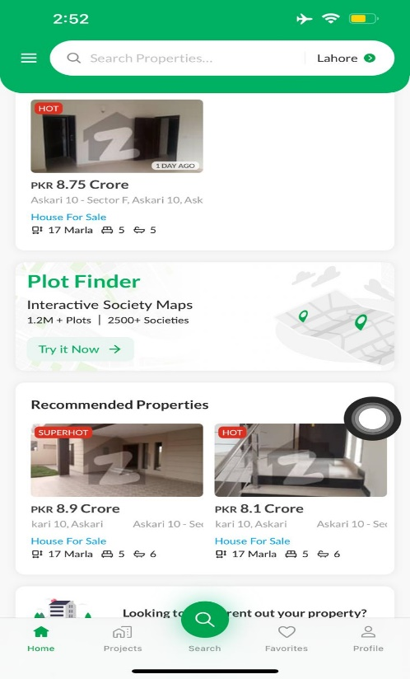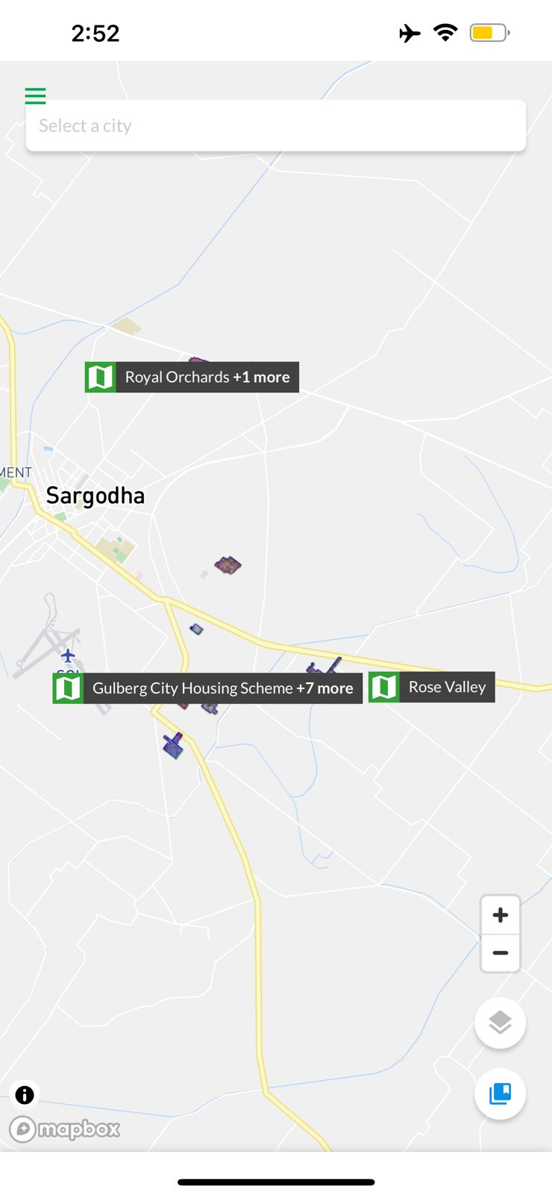

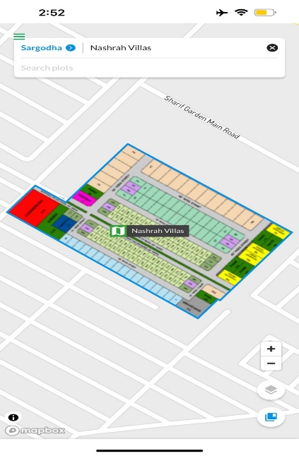

## **Using Recommended Properties**

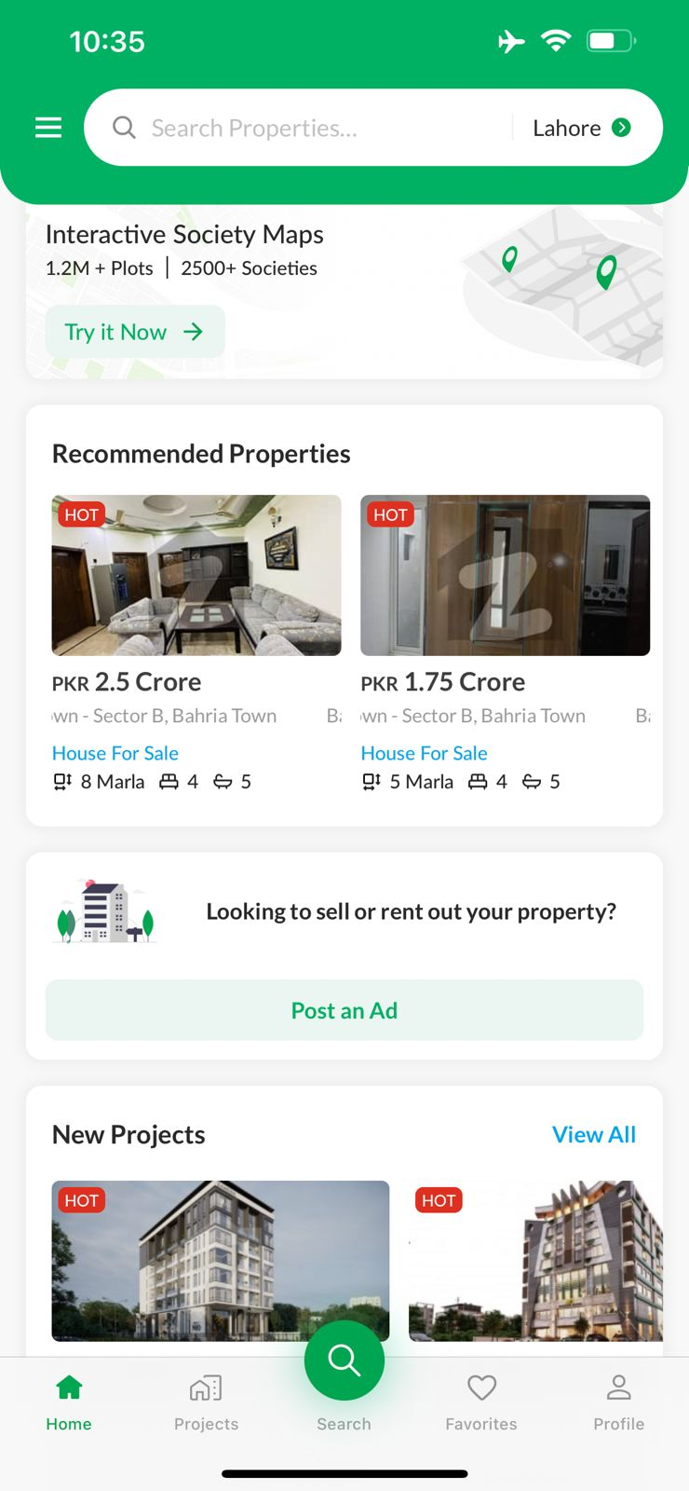

## **Using New Projects**

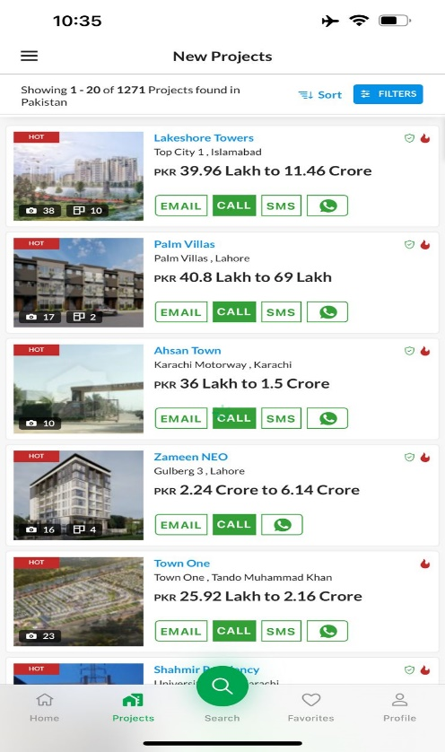

## **Stage 3: Navigating Through List of Properties**

## **Use Filters/Sort/Location etc.**

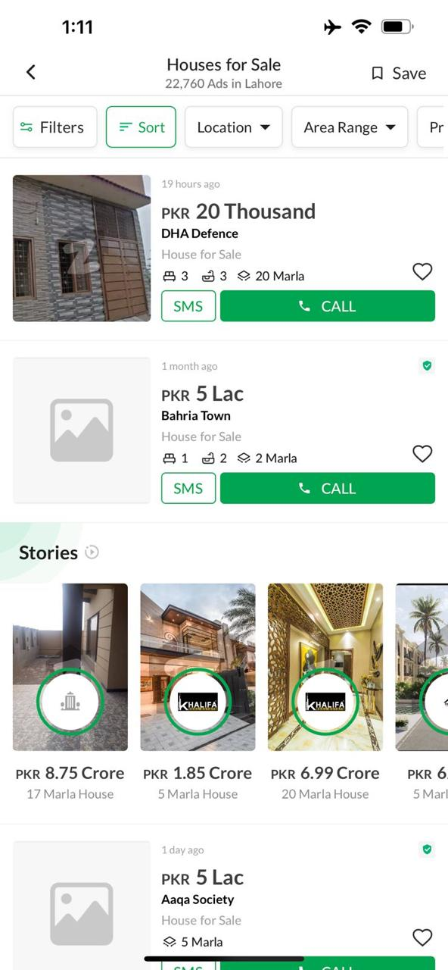

## **Through Stories**

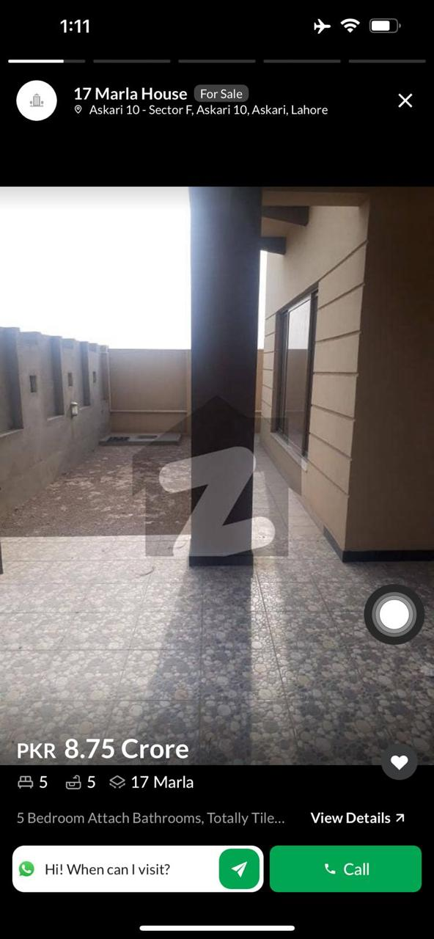

## **View Property Details**

## 

## **Stage 4: Contacting**

## **Using Email**

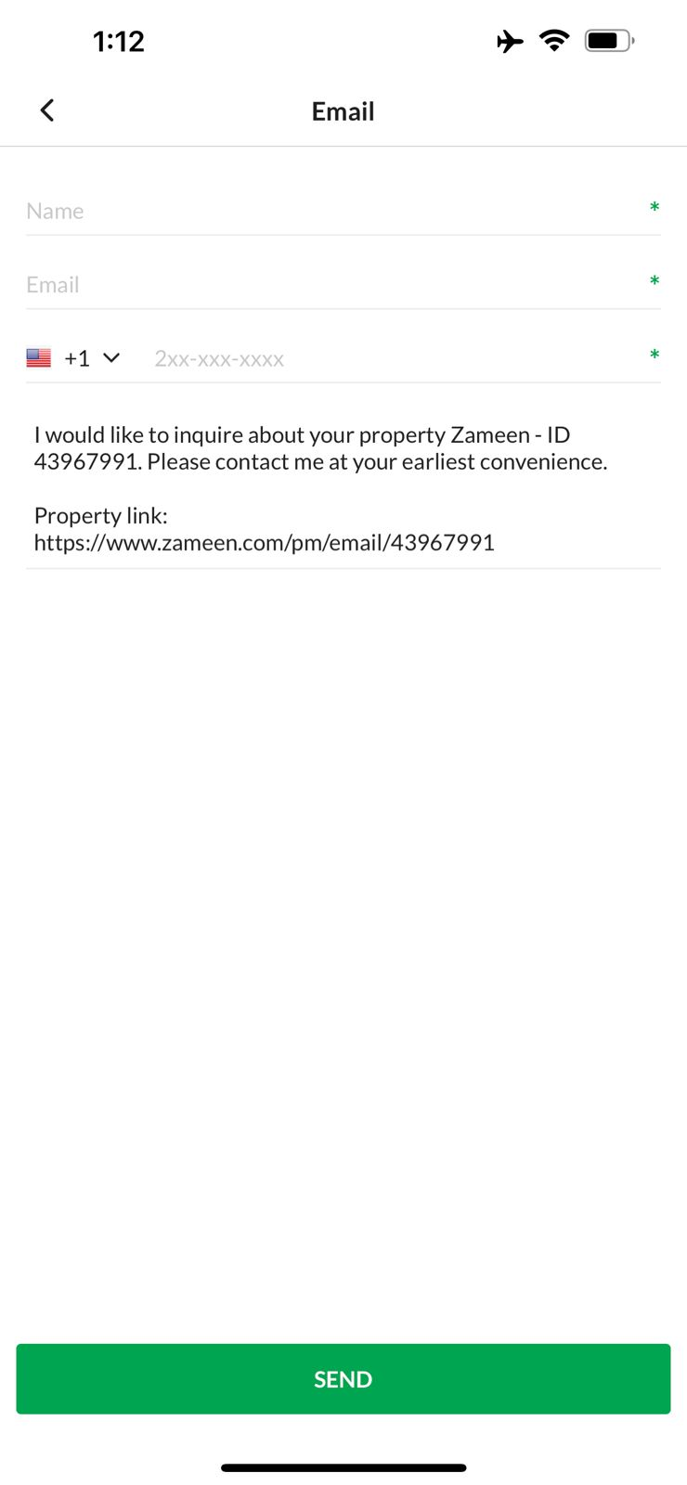

## **Using Call**

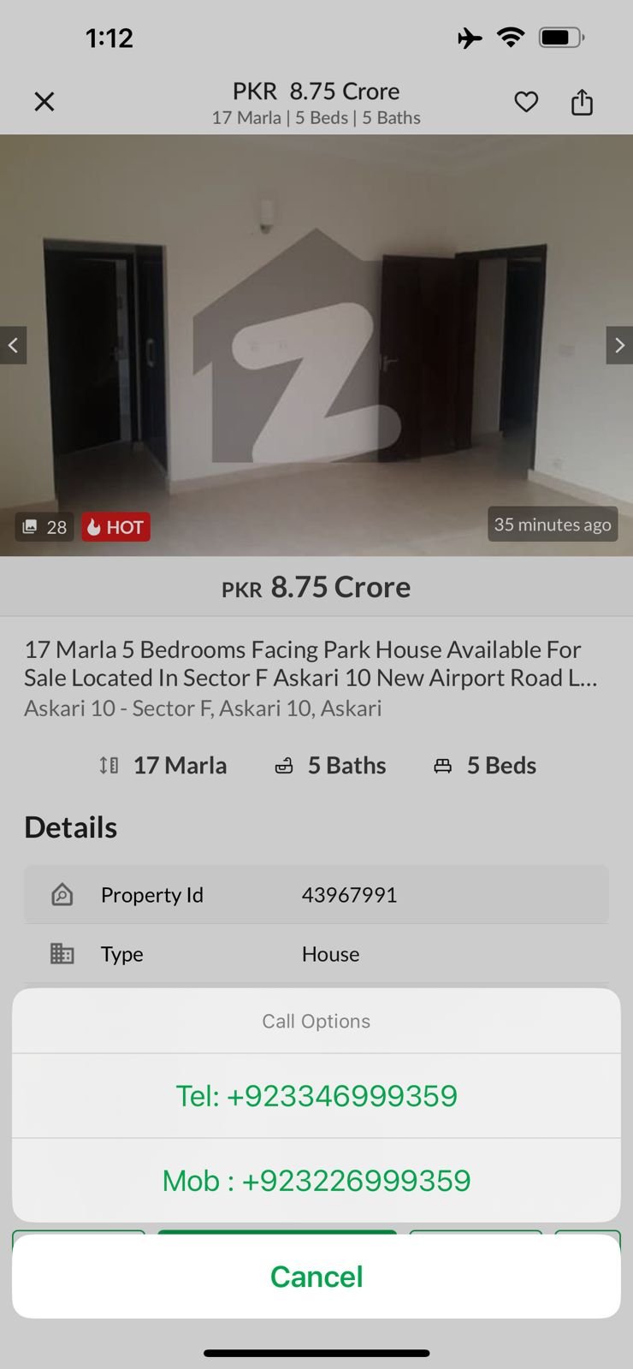

## **Using SMS**

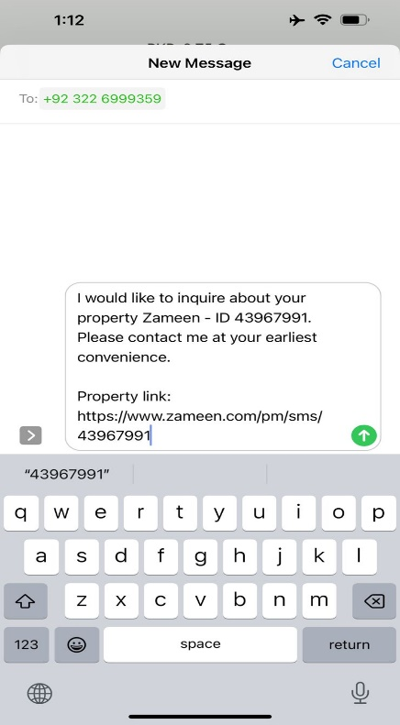

## **Using WhatsApp**

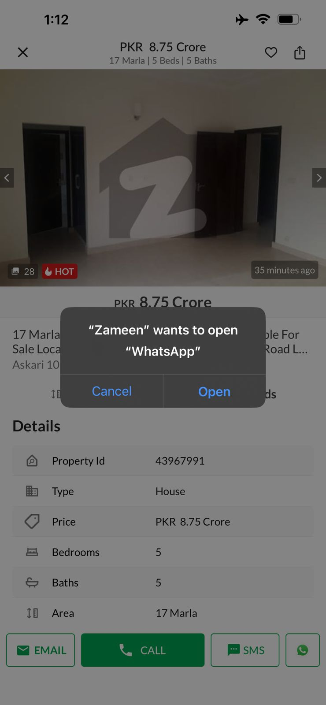

# **Question#02**

## **Part 1: State Transition Diagram**

## **Buying an Agricultural Land via Call**

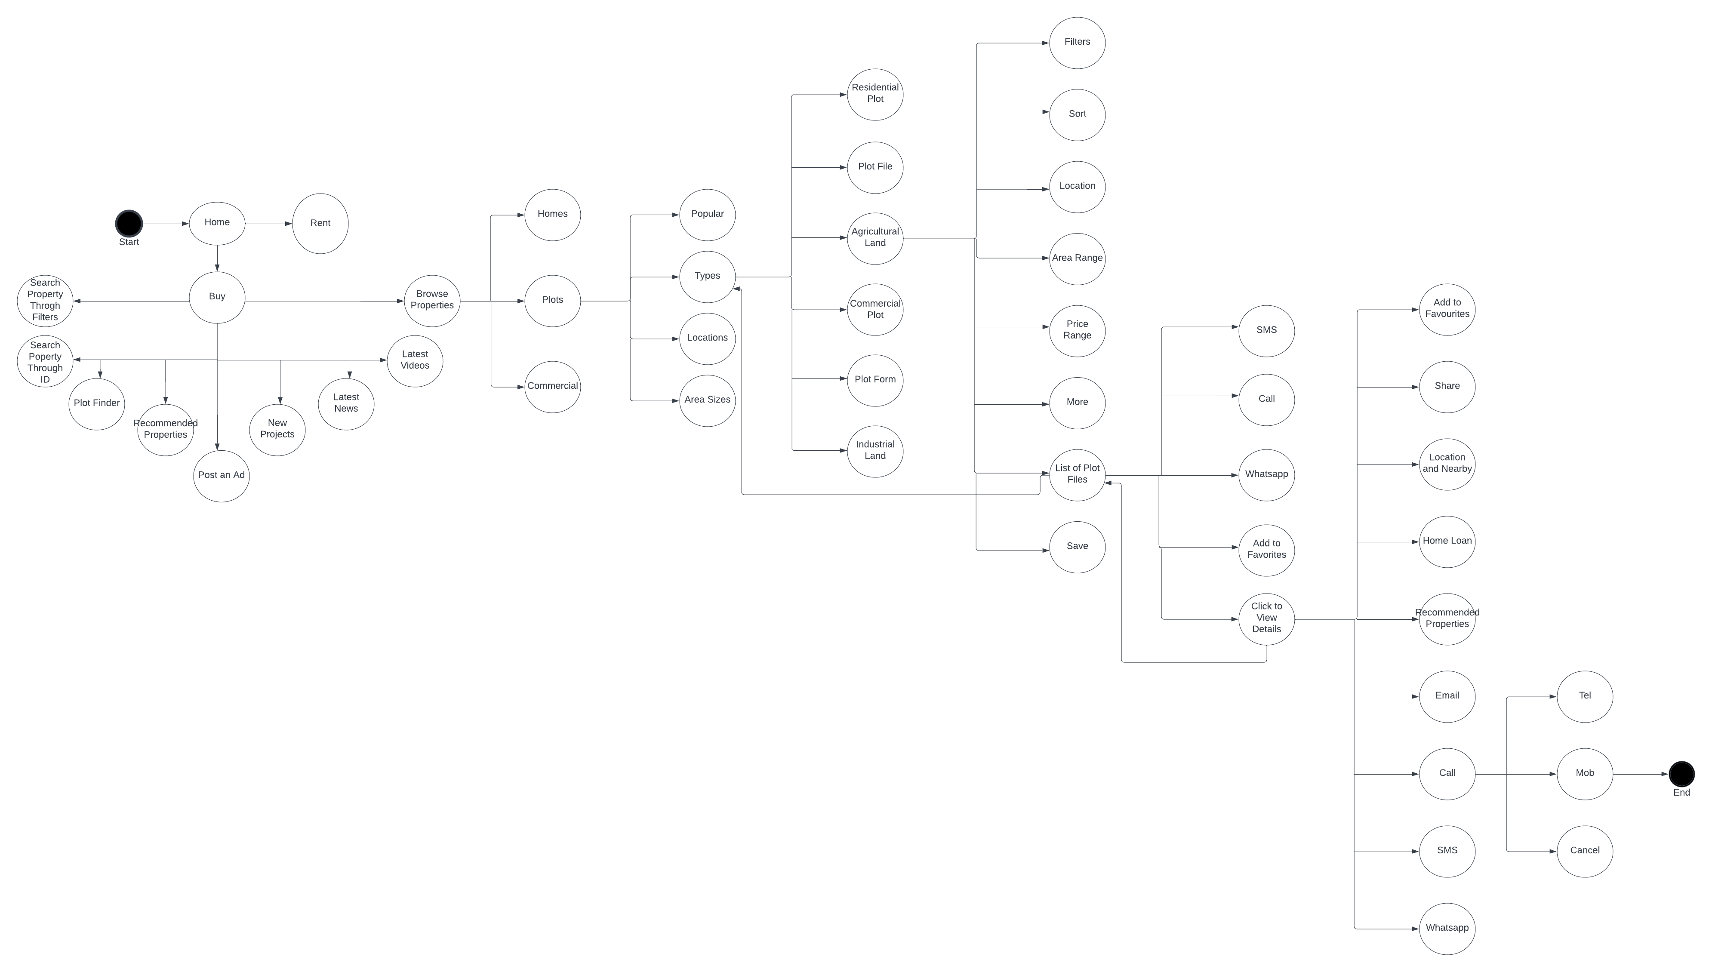

## **Renting a Commercial Office Space via SMS**

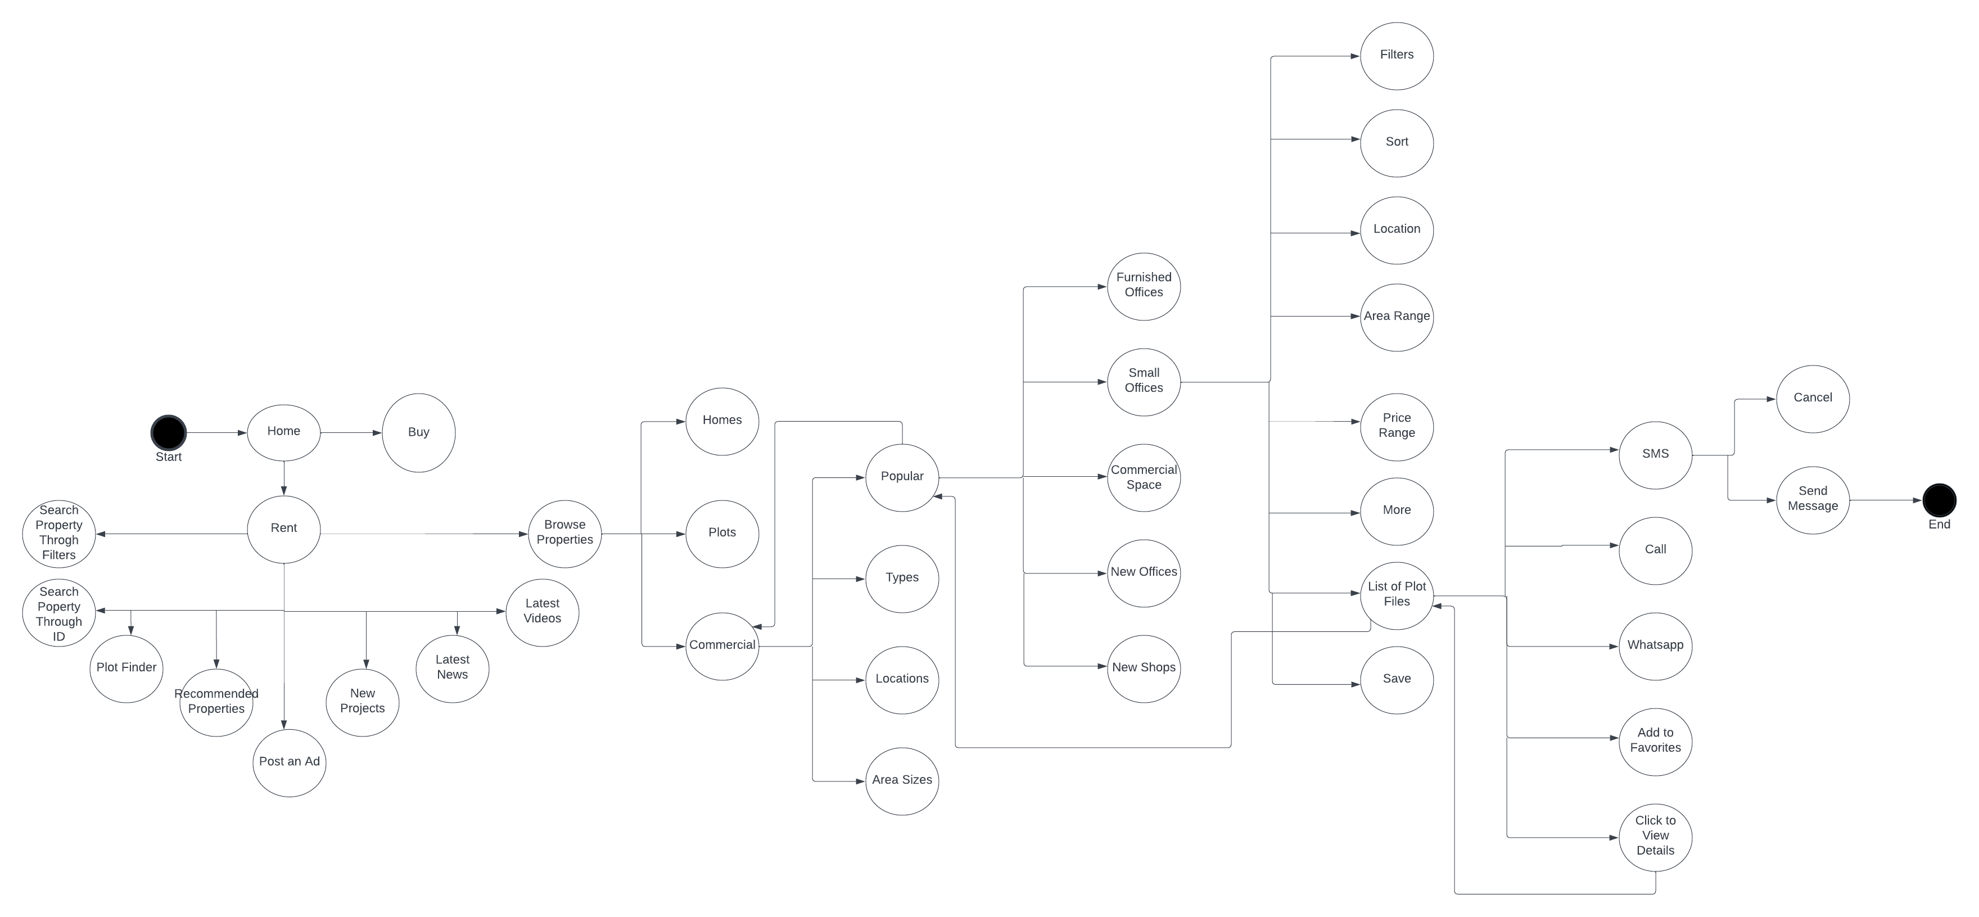

## **Part 1: Process Flow Diagram**

## **Buying an Agricultural Land via Call**

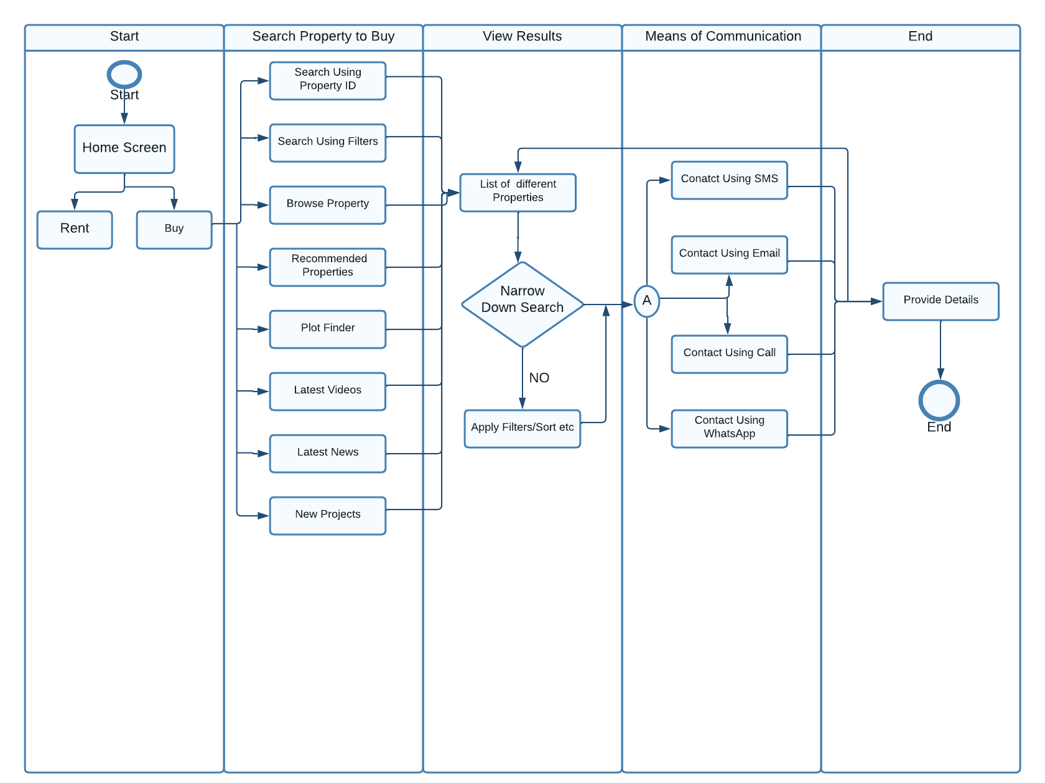

## **Renting a Commercial Office Space via SMS**

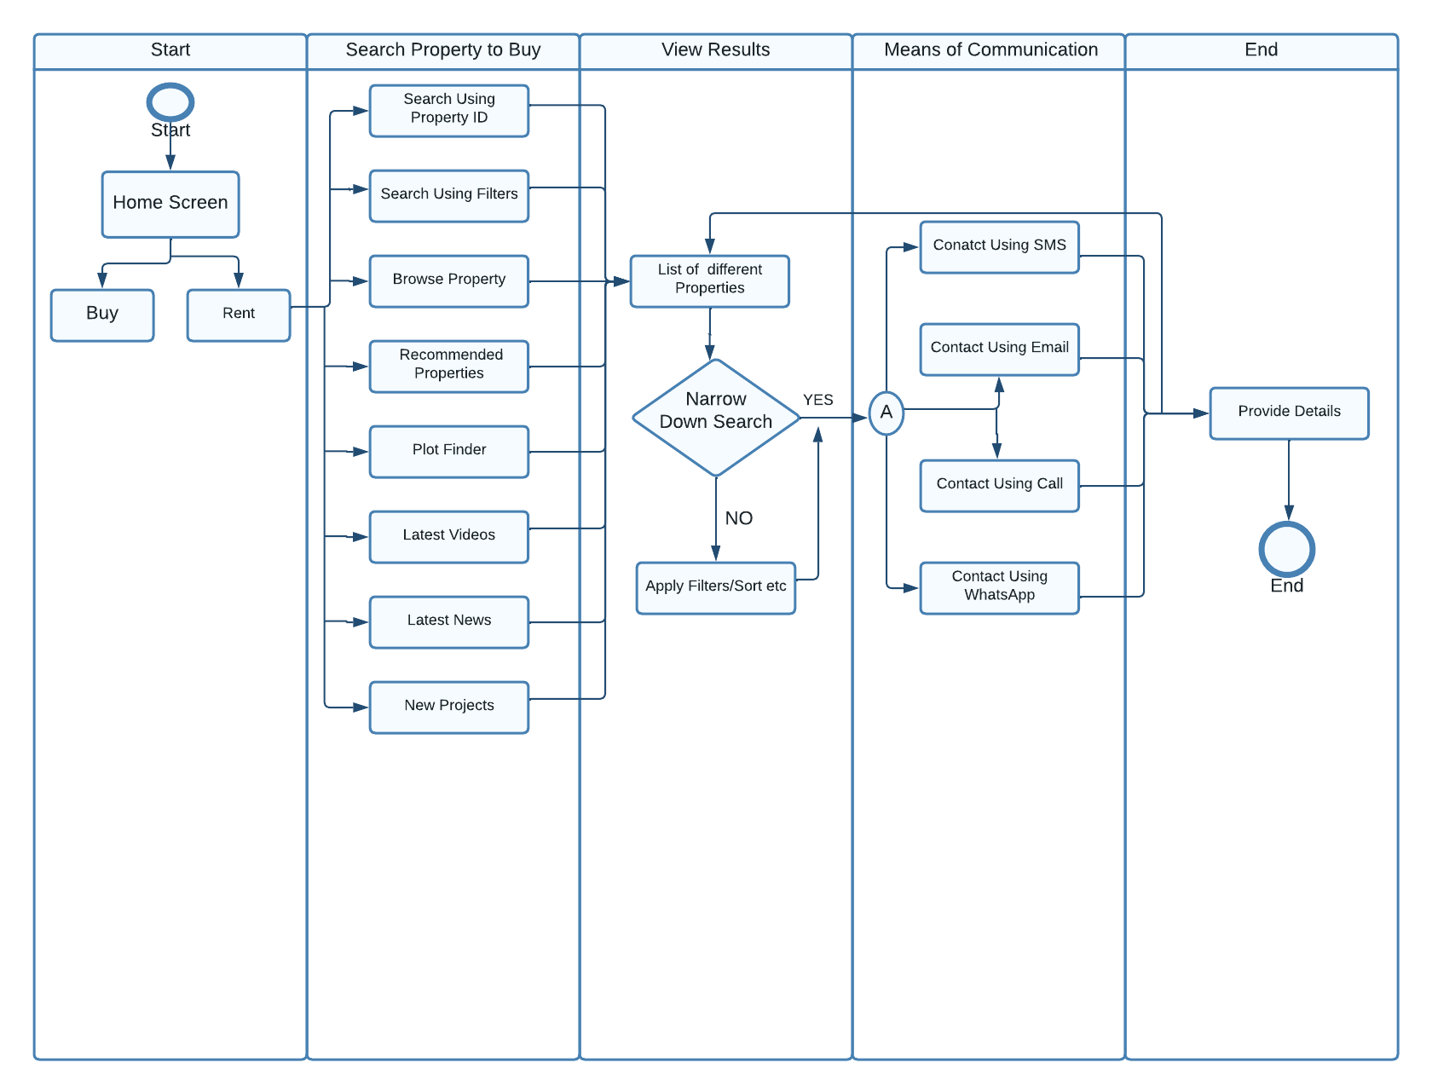

# **Question#03**

## **Engagement KPI for each Stage:**

**Stage 1: Initial Access Steps**

* Number of times the app is installed.
* Number of times the app is opened after being installed.
* Number of users that have created an account on the app.
* Rate of users who turned on notification and location access for the app.

## **Stage 2: Searching Properties for Buying/Renting**

* Total number of times the properties are searched.
* Number of times where the searched results were viewed.
* Number of times where the recommended properties were clicked on.
* Number of times where the new projects were viewed.
* Number of times a property was searched using the property ID option.
* Total amount of time that is spent on searching properties.
* Numbers times the user searched for the property using search property using filters.
* Number of times the properties were searched and viewed using the browse properties categories.

## **Stage 3: Navigating Through List of Properties**

* Time spent viewing properties.
* How far down the pages were scrolled by the users.
* Number of properties added to favorites.
* Number of times the list of properties were sorted.
* Number of times location, area, or price ranged were adjusted.
* Conversion rate from property view to contact initiation.
* Number of time the stories feature were used.
* Click-through rate on recommended properties or related properties.
* Number of time the details of a property were viewed.

## **Stage 4: Contacting**

* Number of contacts initiated.
* Time spent on the contact feature.
* Number of properties that were contacted for.
* Response time from agents or the time taken to respond to the user queries.
* Conversion rate from contact initiation to property visit.

|  |  |  |  |  |
| --- | --- | --- | --- | --- |
| **Metric** |  | **Variables** |  |  |
| **App Installed Rate** | Install count | Install source | Device type |  |
| **App Access Rate** | Total count of app being opened | Time spent on the app | Count of unique users who opened the app |  |
| **Location & Notification Access** | Time spent on screen during location and notification access | Number of users who allow location access | Number of users who turn on notifications |  |
| **Registration Completion Rate** | Total number of users who completed registration. | Total number of users who dropped during registration. | Time spent on registration screen |  |
| **Search Result Views** | Total number of search result views | Time spent on search result pages | Bounce rate from search result pages | Number of unique users who view the search results |
| **Recommended Property Views** | Total number of views on recommended properties | Time spent on recommended properties | Bounce rate from recommended properties | Top viewed recommended properties. |
| **Browse Property** | Most frequently used category | Time spent on each category | Response time of each category | Bounce rate from browse property |
| **Response**  **Time** | Response time of search result | Response time of showing each feature. | Response time of stories | Response time of registration |
| **Property Filters and Sorting** | Total numbers of users apply filters | Most frequently used filters | Time spent on filtered pages | Bounce rate from filtered pages |
| **Property Detail Views** | Total numbers of users views | Top viewed properties | Time spent on the detail page | Bounce back from details page |
| **Story Views** | Total number of story views | Top viewed stories | Time spent on the stories | Story engagement rate |
| **Contacting Actions** | Most frequently used contact method | Time spent on contact screens | Bounce back from contact screens | Total number of times users clicked on contact |

# **Question#04**

|  |  |  |  |
| --- | --- | --- | --- |
| **Variables** | **Availability** | **Variables** | **Availability** |
| Install count | ✓ | Install source | 🗶 |
| Total count of app being opened | ✓ | Time spent on the app | ✓ |
| Time spent on screen during location and notification access | 🗶 | Number of users who allow location access | 🗶 |
| Total number of users who completed registration. | ✓ | Total number of users who dropped during registration. | ✓ |
| Total number of search result views | 🗶 | Time spent on search result pages | ✓ |
| Total number of views on recommended properties | ✓ | Time spent on recommended properties | ✓ |
| Most frequently used category | ✓ | Time spent on each category | ✓ |
| Response time of search result | ✓ | Response time of showing each feature. | 🗶 |
| Total numbers of users apply filters | 🗶 | Most frequently used filters | ✓ |
| Total numbers of users views | ✓ | Top viewed properties | ✓ |
| Total number of story views | ✓ | Top viewed stories | ✓ |
| Most frequently used contact method | ✓ | Time spent on contact screens | ✓ |
| Device type | 🗶 | Number of unique users who view the search results | 🗶 |
| Count of unique users who opened the app | ✓ | Top viewed recommended properties. | ✓ |
| Number of users who turn on notifications | 🗶 | Bounce rate from browse property | ✓ |
| Time spent on registration screen | ✓ | Response time of registration | ✓ |
| Bounce rate from search result pages | ✓ | Bounce rate from filtered pages | ✓ |
| Bounce rate from recommended properties | ✓ | Bounce back from details page | ✓ |
| Response time of each category | ✓ | Story engagement rate | 🗶 |
| Response time of stories | ✓ | Total number of times users clicked on contact | ✓ |
| Time spent on filtered pages | ✓ | Time spent on the stories | ✓ |
| Time spent on the detail page | ✓ | Bounce back from contact screens | ✓ |